Skeletal System – Notes

Functions of the skeletal system:
- Support – Gives shape and provides attachment for muscles.
- Movement – Bones articulate at the joints.
- Protection – The skeleton surrounds and protects many of the vital organs e.g., the brain is protected by the cranium, the reproductive organs are protected by the pelvis and the lungs are protected by the ribcage.
- Storage – Mineral salts and fats are stored by the bones of the skeleton e.g., calcium, phosphorus, sodium and potassium.
- Blood cell production – Red bone marrow in certain bones produces red blood cells.
(Snickers Make Picnic Seem Better)

The axial skeleton consists of the bones that lie along the central axis of the body, providing the main support for erect posture, protects the central nervous system and thoracic organs. Bones include the skull, vertebral column, ribs and sternum.

The appendicular skeleton consists of the bones making up the upper and lower limbs and the bones of the pectoral (shoulder) and pelvic (hips) girdles.

A long bone consists of:
- A shaft, called the diaphysis, making up the main portion of the bone.
- The ends, the epiphyses, which are the enlarged ends of the bone; a thin layer of cartilage, the articular cartilage, covers each epiphysis.
- The diaphysis is a hollow cylinder of compact bone surrounding a cavity. This cavity is used as a fat storage site and is often called the yellow bone marrow cavity.
- The epiphyses have compact bone on the outside but spongy (or cancellous) bone in their central regions. Cancellous bone is more porous and contains many spaces filled with marrow.
- On the outer surface of the bone is a dense white fibrous covering, the periosteum.
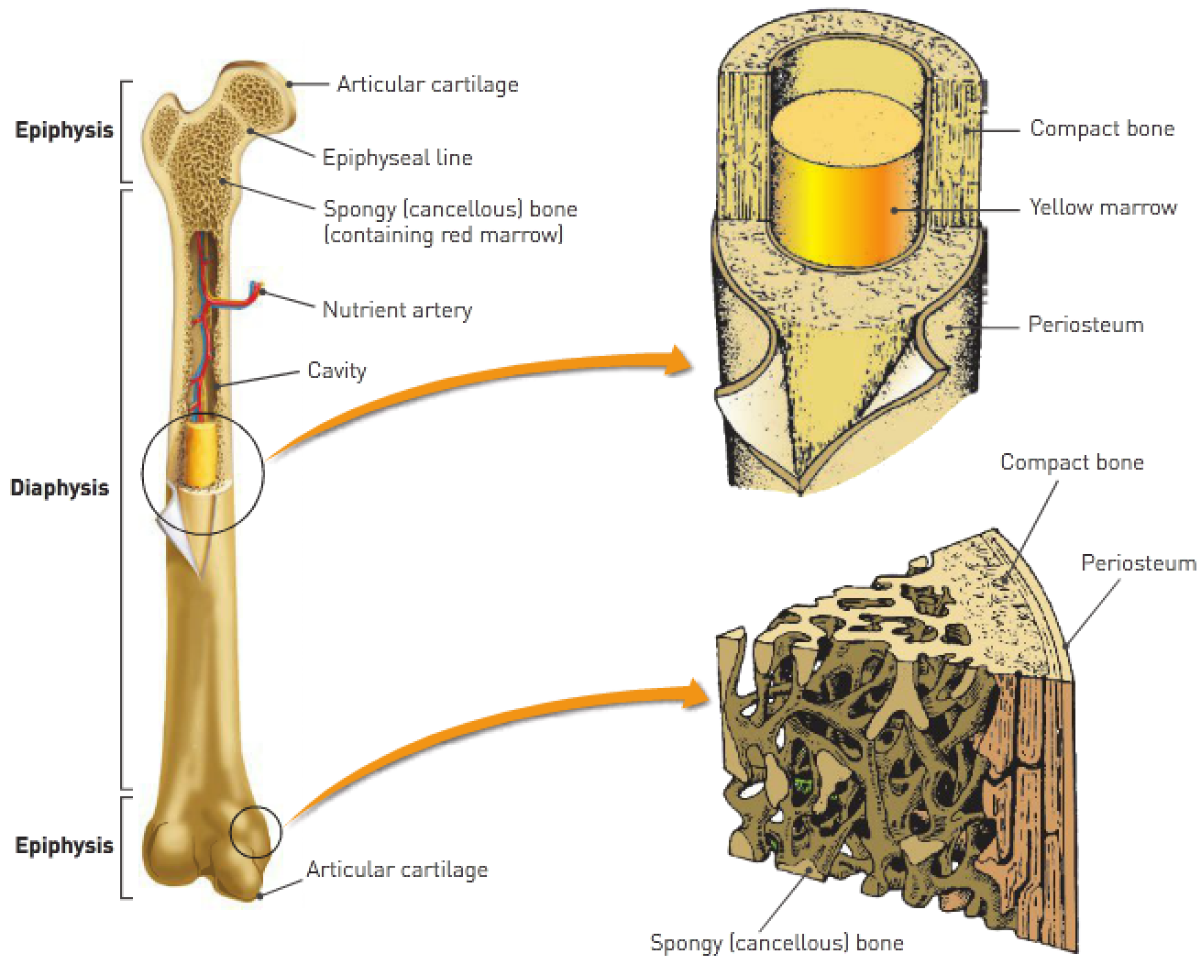

Structure: | Description: | Function:
Diaphysis | The shaft of a long bone. | The main force-bearing potion of a bone.
Epiphysis | The enlarged ends of the bones. | Provides articular surfaces contacting other bones; growth occurs here.
Compact bone | Very hard, dense connective tissue. | Forms the diaphysis and the outer part of the long bone.
Yellow bone marrow cavity | Cavity in the middle of a long bone; also called the medullary cavity. | Hollow cavity that stores fatty bone marrow.
Spongy bone | An irregular arrangement of thin bony plates called trabeculae. | Hard tough bone fibers with many spaces; strong and lightweight.
Articular cartilage | Shiny, smooth, tough layer on the articular surfaces of bones. | Friction-free surfaces for contact with other bones.
Periosteum | Tough, fibrous outer covering on the epiphyses of bones. | Protection of bones and attachment of muscles.

Microscopic structure of bone:
- Bone is a connective tissue.
- Connective tissues consist of cells separated form each other by large amounts of non-cellular material called matrix where inorganic salts are deposited. These increase its rigidity.
- Consists of cells separated by matrix made up of inorganic salts (mostly calcium and phosphate).
- Compact bone is made of many similar units called Haversian systems or osteons.
- Spongy bone is made of thin boney plates called trabeculae.

Key terms to be able to identify and explain:
- Osteon.
- Lamellae.
- Canaliculi.
- Osteocyte.
- Trabeculae.
- Haversian canal.
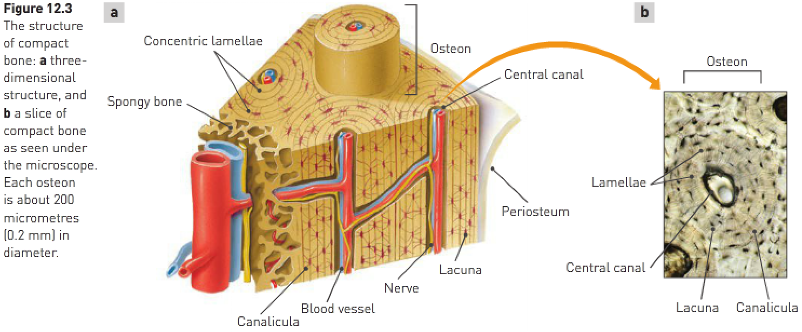
- At the centre of each osteon is a central canal (Haversian canal) around which are concentric layers of body matrix called lamellar.
- Between the lamellar are small spaces in the matrix called the lacunae.
- A bone cell, or osteocyte, occupies each lacuna and tiny canals known as canaliculi run between the lacunae.
- Projections from the osteocytes enter the canaliculi and make contact with adjacent bone osteocytes. In this way, materials can be passed from cell to cell.
- The central canal in the middle of each osteon always contains at least one blood capillary and may contain nerves and lymph capillaries.
- Osteons of compact bone run parallel to the long axis of the bone, giving it maximum strength.
- Spongy (cancellous) bone consists of an irregular arrangement of thin, bony plates called trabeculae.
- Bone cells occupy spaces in the trabeculae but the lamellae aren’t arranged in concentric layers, and nerves and blood vessels pass through irregular spaces in the matrix.
- In an adult, the bones of the skeletal system are capable of repair and continue their function of blood cell formation and storage.

Cartilage:
- Contains numerous fibres made of a protein called collagen.
- Collagen is embedded in a firm matrix of a protein-carbohydrate complex called chondrin.
- Firm matrix enables cartilage to function as a structural support.
- Presence of fibres gives cartilage a certain amount of flexibility.

Microscopic structure of cartilage:
- Cartilage has a firm matrix which has spaces collagen fibres as well as cartilage cells called chondroblasts.
- Chondroblasts produce matrix and gradually become surrounded by it until they’re trapped in small spaces called lacunae.
- Once trapped in lacunae, the chondroblasts are considered to be mature and are known as chondrocytes.
- The collagen fibres in the matrix range in thickness. This variation in fibrous structure is used to classify cartilage into 3 types:
- Hyaline cartilage.
- Elastic cartilage.
- Fibrocartilage.

Type: | Structure: | Characteristics: | Location:
Hyaline | Contains many closely packed collagen fibres in the matrix. | Great strength, toughness and flexibility. | Rings of bronchi and trachea and on articulating bone surfaces.
Elastic | Has conspicuous elastic fibres and the collagen fibers aren’t so tightly packed. | Flexible elastic support. | External ear and epiglottis.
Fibrocartilage | Thick coarse collagen fibers in bundles. | Strength and toughness but can be slightly compressed; ideal for supporting weight. | Intervertebral discs, articular cartilage of knee joint, between pubic bones and joining 2 sides of the pelvis.

- Joints can be classified by their structure and the amount of movement they allow.
Structure | Joint cavity: | Movement:
Fibrous | None | None
Cartilaginous | None | None or slight
Synovial | Present | Freely moveable

- The blood supply to cartilage comes from blood vessels located in the inner layer of the perichondrium – a fibrous membrane of connective tissue that covers the external surface of cartilage, except where the cartilage forms the articular surface of a joint.

Structure of a synovial joint:
An articular capsule surrounds and encloses the joint. The capsule comprises of 2 layers:
- Outer layer (fibrous capsule) consists of dense, fibrous connective tissue attached to the periosteum of the articulating bones. Its flexibility permits movement at the joint, whereas its strength resists dislocation. The fibrous capsule is one of the principal structures that hold the bones together.
- Synovial membrane makes up the inner layer of the capsule. It consists of loose connective tissue, the inner surface of which is well supplied with blood capillaries. The synovial membrane lines the entire joint cavity except the articular cartilages and a structure called the articular disc (if present).

Joints:
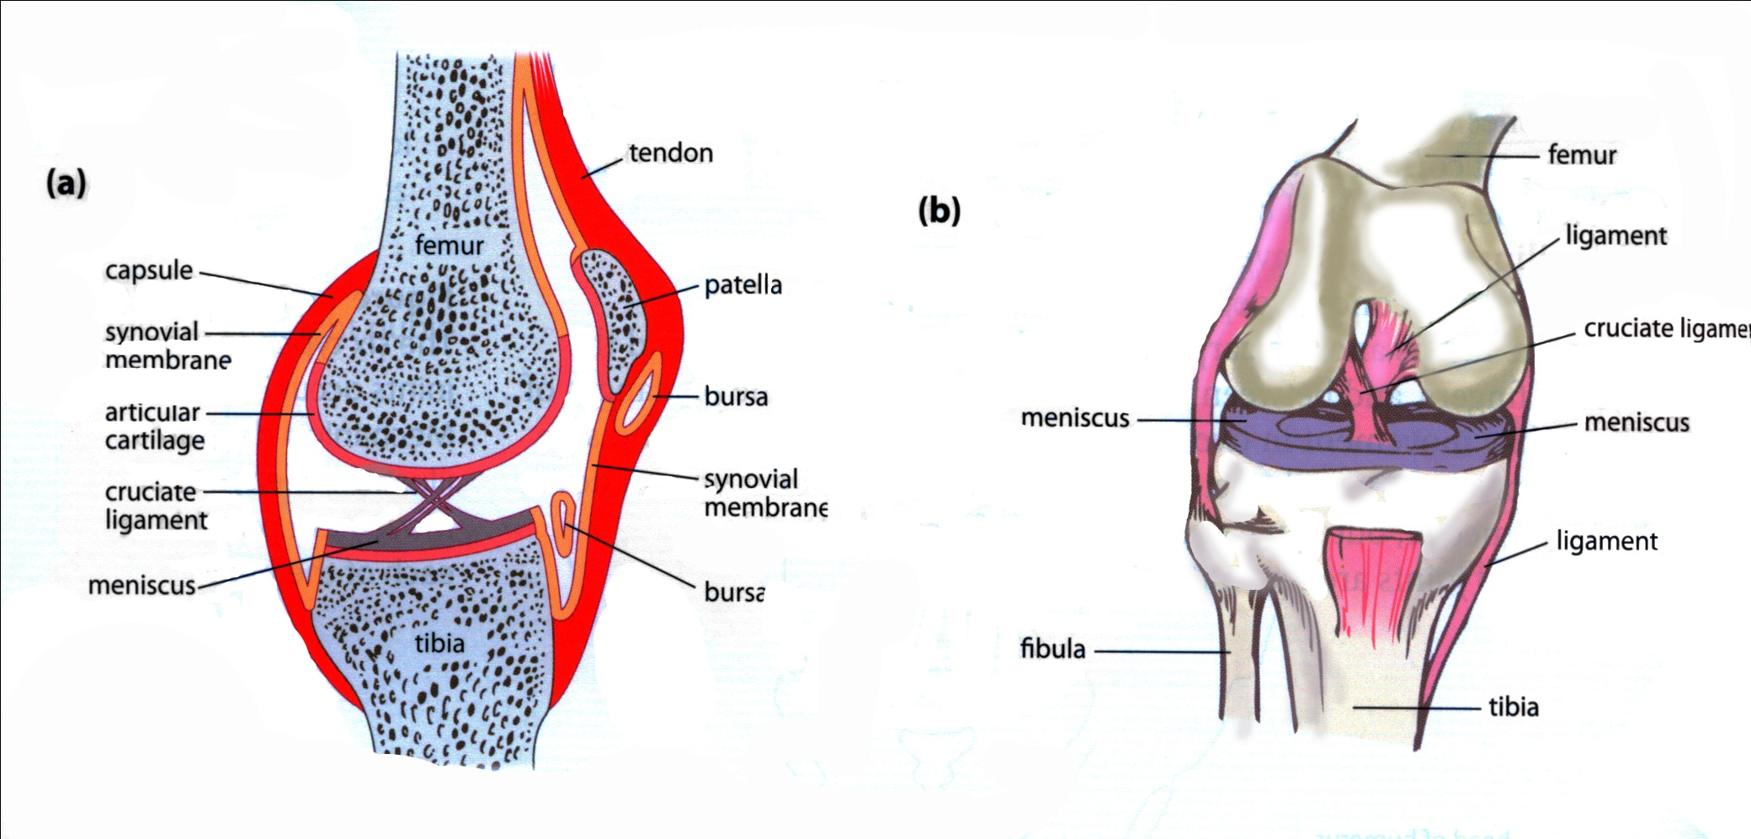

Name: | Description: | Function:
Capsule | Cartilage sac composed of 2 layers – an outer fibrous layer and an inner membrane. | Surrounds and encloses the joint.
Fibrous capsule. | Dense fibrous connective tissue attached to the periosteum of the articulating bones. | Flexibility permits movement and strength; prevents dislocation.
Synovial membrane | Loose connective tissue inside the fibrous capsule well-supplied with blood vessels. | Secretes synovial fluid into the synovial cavity.
Synovial fluid | Similar in appearance and consistency to egg white; forms a thin film over surfaces in the capsule; contains phagocytic cells. | Lubricates the joint, provides nourishment for cells of the articular cartilage and removes microbes and debris.
Articular cartilage | Smooth tough cartilage that covers articulating surfaces of the joint. | Provides smooth surfaces that have little friction.
Articular discs | Fibrocartilage menisci extend inwards from articular cartilage. | Divide the synovial cavity into 2, directing synovial fluid to areas of greatest friction.
Bursae | Small sacs of synovial fluid. | Reduce friction between bones and ligaments or tendons, or between bone and skin.
Accessory ligaments | Extra ligaments in the joint. | Hold the bones together, particularly during extended movement.
Several factors keep the articular surfaces of synovial joints in contact with each other:
- Fit of the articulating bones.
- Strength of the joint ligaments.
- Tension provided by the muscles around the joint.

Synovial joints are classified by type of movement that occurs between the articulating surfaces of the bones:
- Ball-and-socket joints – Form when the spherical head of one bone fits into a cup-like cavity of another. Examples: head of the humerus fits into a depression in the scapula and the head of the femur articulates with the pelvis.
- Hinge joints – Allow movement in one plane only, much like that of a hinged door; they form when the convex surface of one bone fis into the concave surface of another. Example: Elbow and knee.
- Pivot joints – Formed when the rounded, pointed or conical end of one bone articulates with a ring, formed partly by bone and partly by a ligament. Example: Joint between the first vertebrae, on which the head is balanced and the second vertebrae which allows the head to rotate.
- Gliding joints – Allow movement in any direction in a side-to-side or back-and-forth motion, restricted only by the ligaments or bony processes surrounding the joint. Example: Between carpal bones, tarsal bones, sternum and clavicle, and the scapula and clavicle.
- Saddle joint – 2 bones forming the joint are both saddle-shaped – concave in one direction and convex in the other; they fit together in such a way that they allow both side-to-side and back-and-forth movements.
- Condyloid (ellipsoid) joints – Have one surface of bone slightly convex that fits into a slightly concave depression in another bone; they allow movement in 2 directions e.g., up and down and side to side. Example: Between the radius and carpal bones, the metacarpal bones and the phalanges of the fingers, and between the metatarsal bones and the phalanges of the toes.
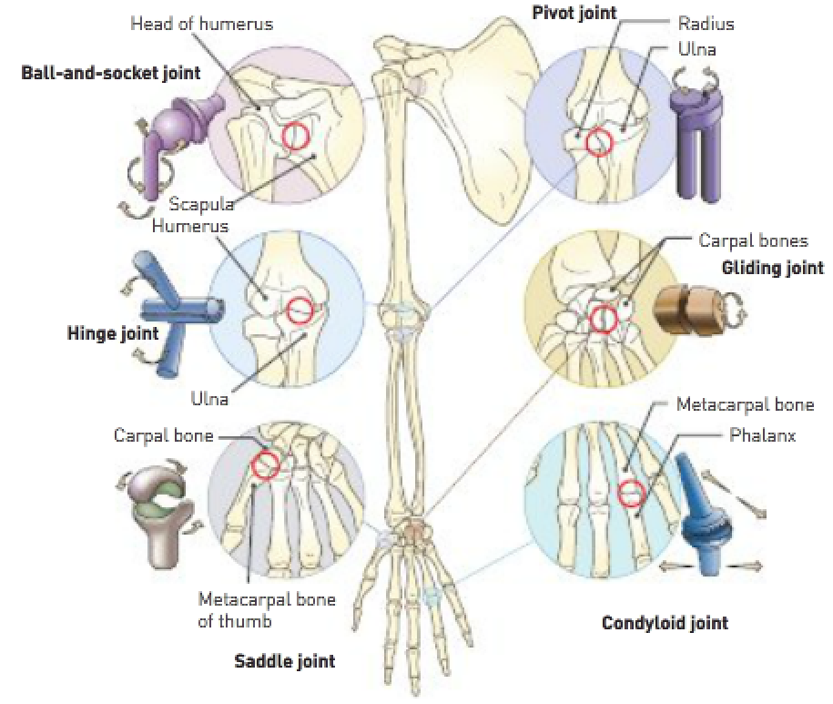
Movement of a joint:
- Flexion (bending) – Usually decreases the angle between the articulating bones.
- Extension (straightening) – Usually increases the angle between the articulating bones.
- Abduction – Movement away from the midline of the body.
- Adduction – Movement towards the midline of the body.
- Rotation – Movement of a bone around its long axis.

